**Assignment 08 – Drupal 9 CMS Website (Basic Pages)**

**Instructions for completing template:**Replace **[bracketed red text]** with the requested information or screen capture.  
Replace **bracketed red text with black text** and then remove the brackets.  
Do not include full screen shot images, or full screen shots that are reduced in size. Use a snippet tool to capture parts of the screen and insert those images into the template.  
Do not remove tags from this template. Please answer all questions.  
**Please do not alter the formatting or delete parts of this template.**  
Assignment questions are not as detailed as activity questions.   
The assignment is where you demonstrate understanding of the material.

**Part A: Student Information**

1. **Student Name: [SYED AFTAABUDDIN] [A01]**
2. **Student Email: [syedaftab299@gmail.com] [A02]**
3. **Student Cell: [7737960029] OPTIONAL**
4. **What day and date did you start this assignment: [Wednesday 03/03/2021] [A03]**

**Go back to the instructions and begin work on part B.  
  
Part B: Create 1 Shared Web Host, Localhost or PaaS Drupal 8-9 Website**

(1) Shared Web Host Drupal 9 CMS Site Information:

1. Shared Web Host Name: [Namecheap] [B01]  
   Shared Web Host Site Admin Username: [saftaabu] [B02]   
   Shared Web Host Site Admin Password: [50297006@Sps] [B03]  
   Domain Name: [namecheap.com] [B04]  
     
   Website Admin Username: [saftaabu] [B05]  
   Website Admin Password: [&>j#s2FL$X@w$] [B06]  
   Database Name: [drup724] [B07]  
   Table Prefix: [druj_] [B08]  
   Drupal CMS Website URL: [https://syedaftab.tech/mod08assign08/] [B09]  
   Drupal version built (version.minor.patch): [Drupal 9.1.4][B10]

**-OR-**

1. Localhost - Acquia Dev Desktop web host Drupal 9 site information [B01-D]
   1. Drupal major.minor.patch version built: [ Drupal version here ]
   2. **Site name:** [site name here]
   3. **Site email address:** [email address here]
   4. **Site Username:** [website username here]
   5. **Site Password:** [website password here ]

-OR-

(2) Pantheon – Drupal 8-9 CMS Site Information: Drupal 8 if 9 not supported

**Drupal Version Built (major.minor.patch): [Drupal version here]**

**Assignment Website Site Name:** **[Site Name here] [B01]**

**WEBSITE Admin Username:** **[Admin Username here] [B02]**

**WEBSITE Admin Password:** **[Admin Password here] [B03]**

**Pantheon Frontend Website URL:** **[Frontend website URL here] [B04]**

**Go back to the instructions and begin work on part C.  
  
Part C: Harden Shared Web Host, Localhost or PaaS Drupal Site**

1. SCREEN CAPTURE of the backend Admin toolbar > Configuration > Account settings, with the REGISTRATION AND CANCELATION section visible **[C01]**  
   **[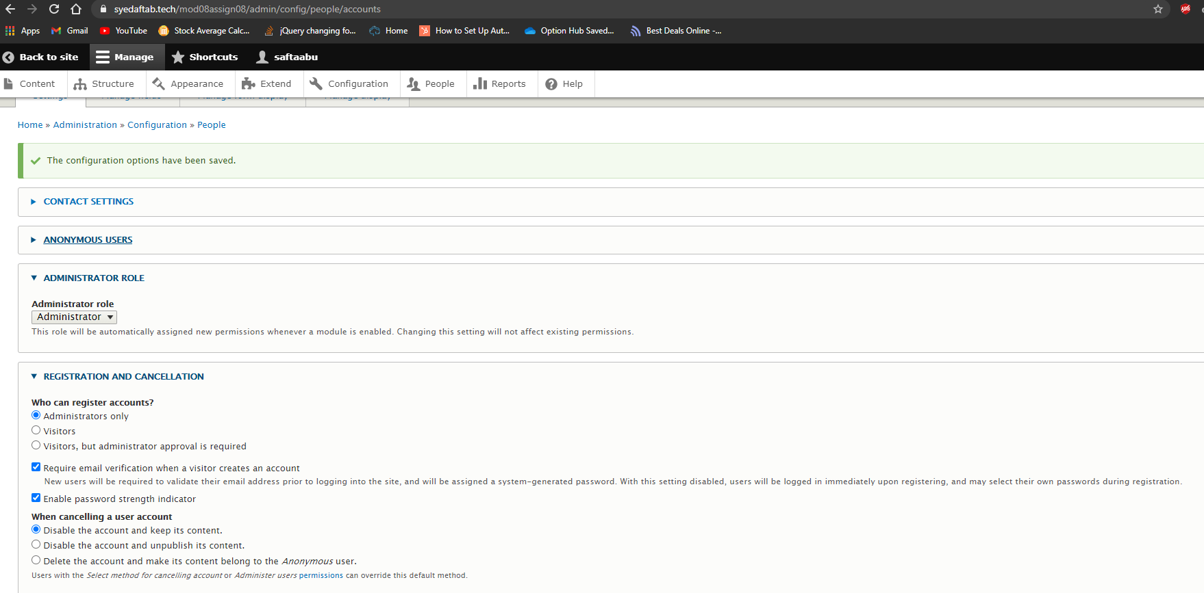]**
2. Screen capture of the Drupal 8 front-end website > User login page **[C02]**  
   **[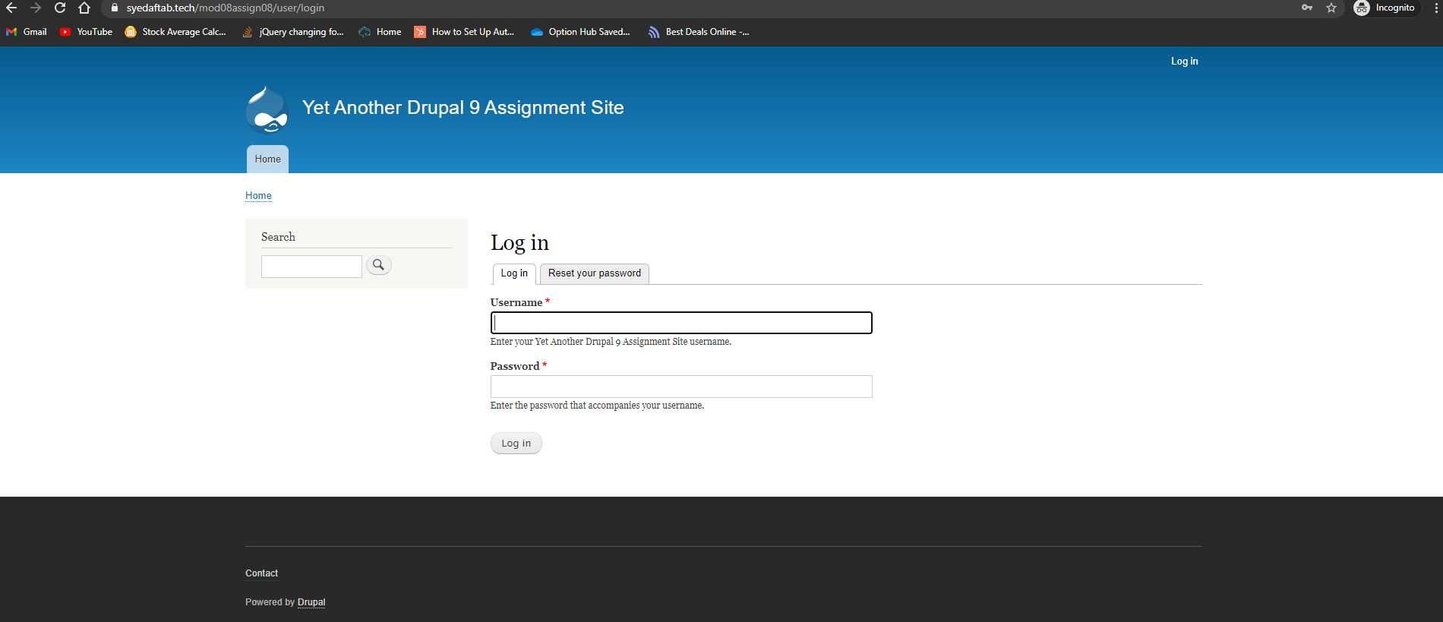]**

**Go back to the instructions and begin work on part D.**

**Part D: Answer Template Questions [D]**

**Based on topics covered in IT320 Module 07 and Module 08**

1. What is the purpose of Published check box on the Administration Basic page and Article content template pages? [D01]  
   **[**The purpose is to publish the content everytime by default so even if you make changes, the content updates itself. You don’t have to publish again and again. **]**
2. What are the steps to add a new user to a Drupal 8-9 site? [D02]  
   **[**Admin Panel > People > Add User > Fill out the form > Create New Account**]**
3. What are the steps for finding, validating, installing, and activating a new DEFAULT Drupal 8-9 front-end client-facing theme? [D03]  
   **[**Step 1: Look for a good theme, check if it is compatible with your version of drupal.  
   Step 2: Look for the date of the release, make sure to pick the latest, check for dependencies, look for the reviews and reported site usage. **]**
4. What are the steps for finding, validating, installing, and activating a new Drupal 8-9 back-end administration theme? [D04]  
   [Step 1: Look for a good theme, check if its compatible with your version of drupal.  
   Step 2: Look for the date of the release, make sure to pick the latest, check for dependencies, look for the reviews and reported site usage.]
5. What are the names of the three (3) types of Drupal modules? [D05]  
   [Custom Modules, Core Modules, and Contributed Modules]
6. What are the names of the 3 files used to create a Drupal 8-9 custom module? [D06]  
   [module_name.info.yml | module_name.routing.yml | module_name_Controller.php]
7. If a Drupal module project page has the following Requires Drupal [ ^8 || ^9 ] what versions of Drupal can it be installed on? [D07]  
   [Both. Drupal 8 or Drupal 9. And any version of 8 or 9 drupal. ]
8. If a Drupal module project page has the following Requires Drupal [ ^8.8 || ^9.0.1] what versions of Drupal can it be installed on? [D08]  
   [You can’t install the versions below drupal 8 which is ( < drupal 8.8) and no drupal 9.0.0]
9. If a Drupal module project page has the following Requires Drupal [ 7.x] what versions of Drupal can it be installed on? [D09]  
   [Drupal 7 only. 7.x means you can download any version of drupal 7.(ex. 7.2.2, 7.3.4)]
10. If a Drupal module project page has the following Requires Drupal [ 8.x] what versions of Drupal can it be installed on? [D10]  
    [Drupal 8. 8.x means you can download any version of drupal 8. (ex. 8.2.4 or 8.4.5)]

**Go back to the instructions and begin work on part E.**

**Part E -** Extend the Shared (or PaaS) Drupal 8-9 Site with Core Modules

**1. SCREEN CAPTURE of the backend list of Admin toolbar > Extend with Telephone module enabled and visible.   
[E01]  
[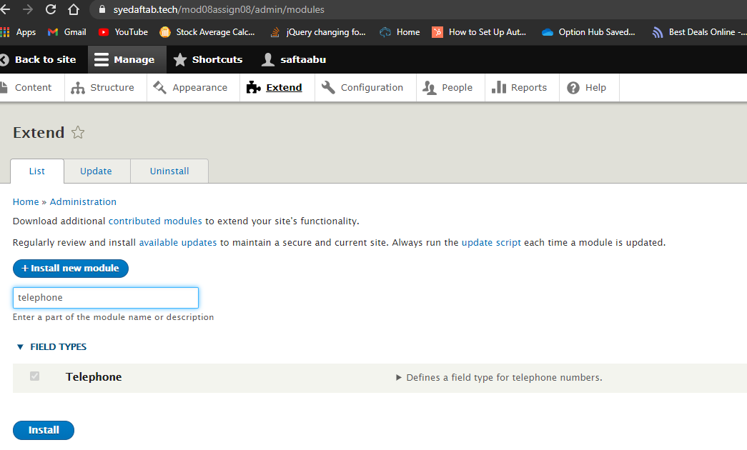]**

**2. SCREEN CAPTURE of the backend of Admin toolbar > Structure > Content types > My telephone test   
[E02]  
[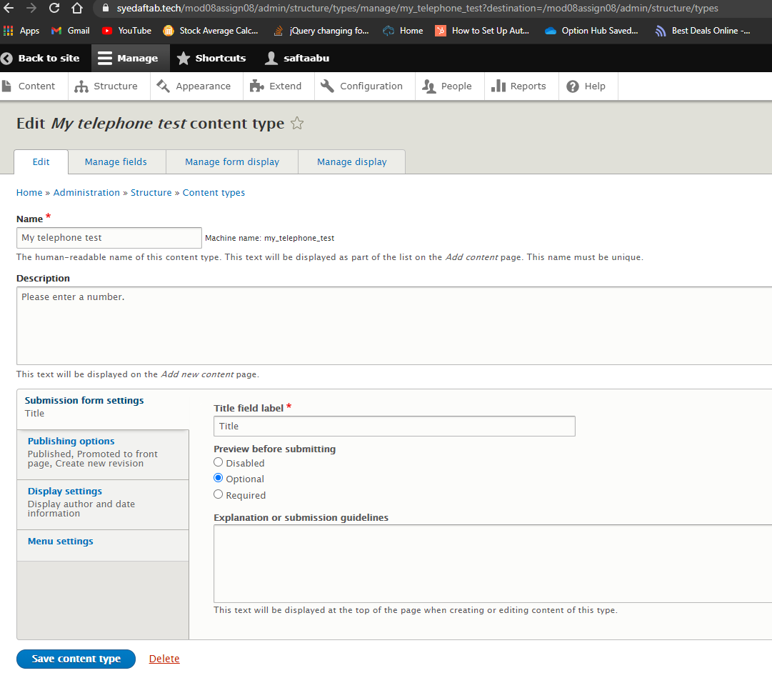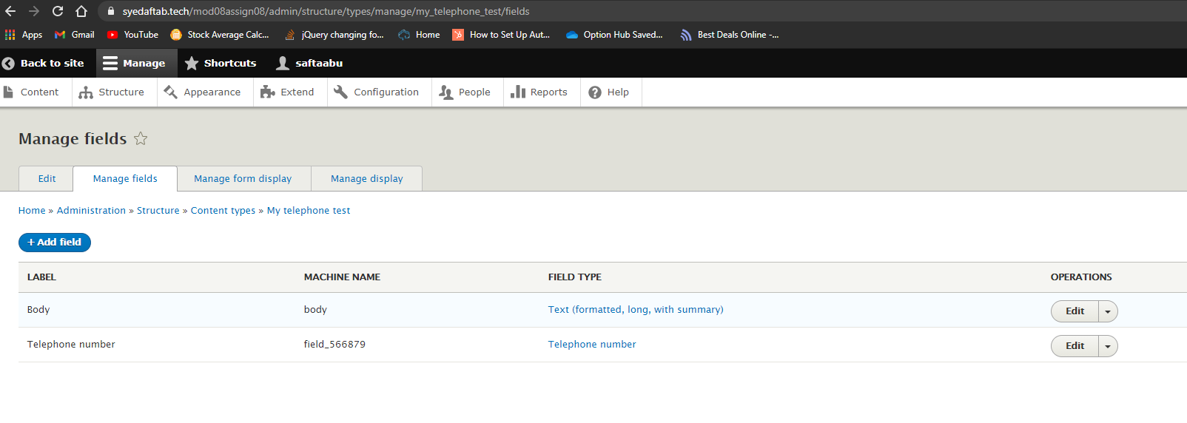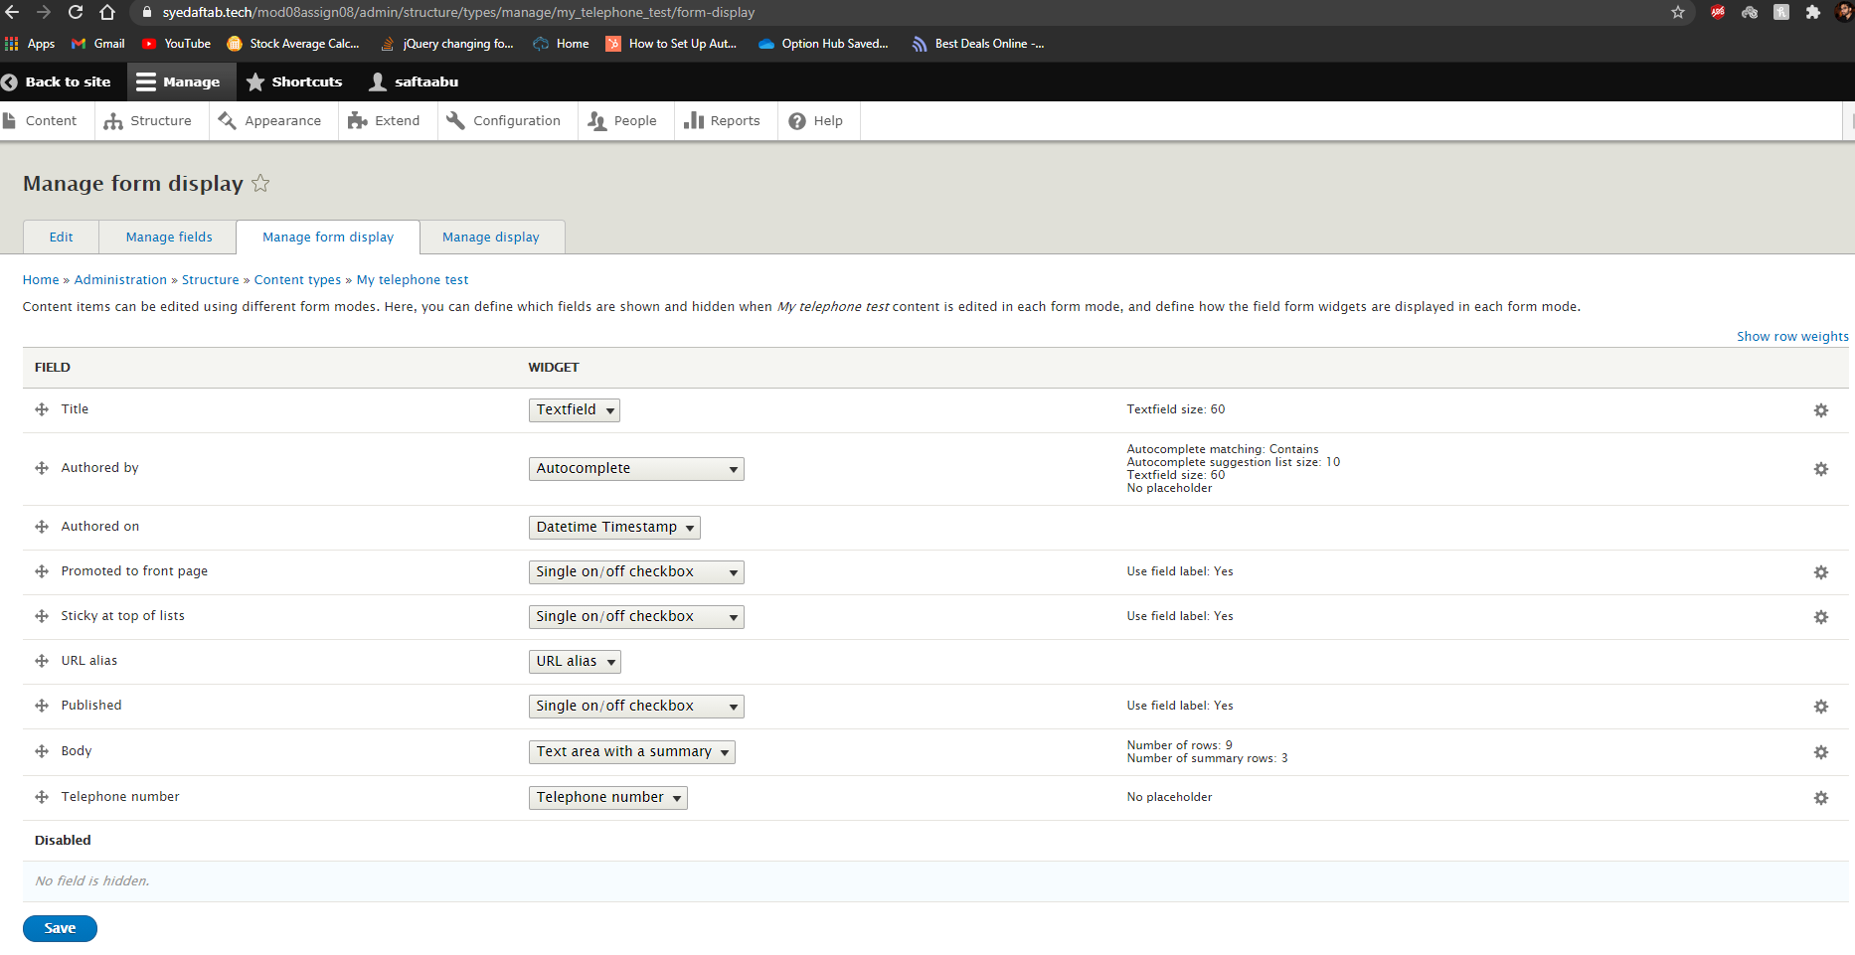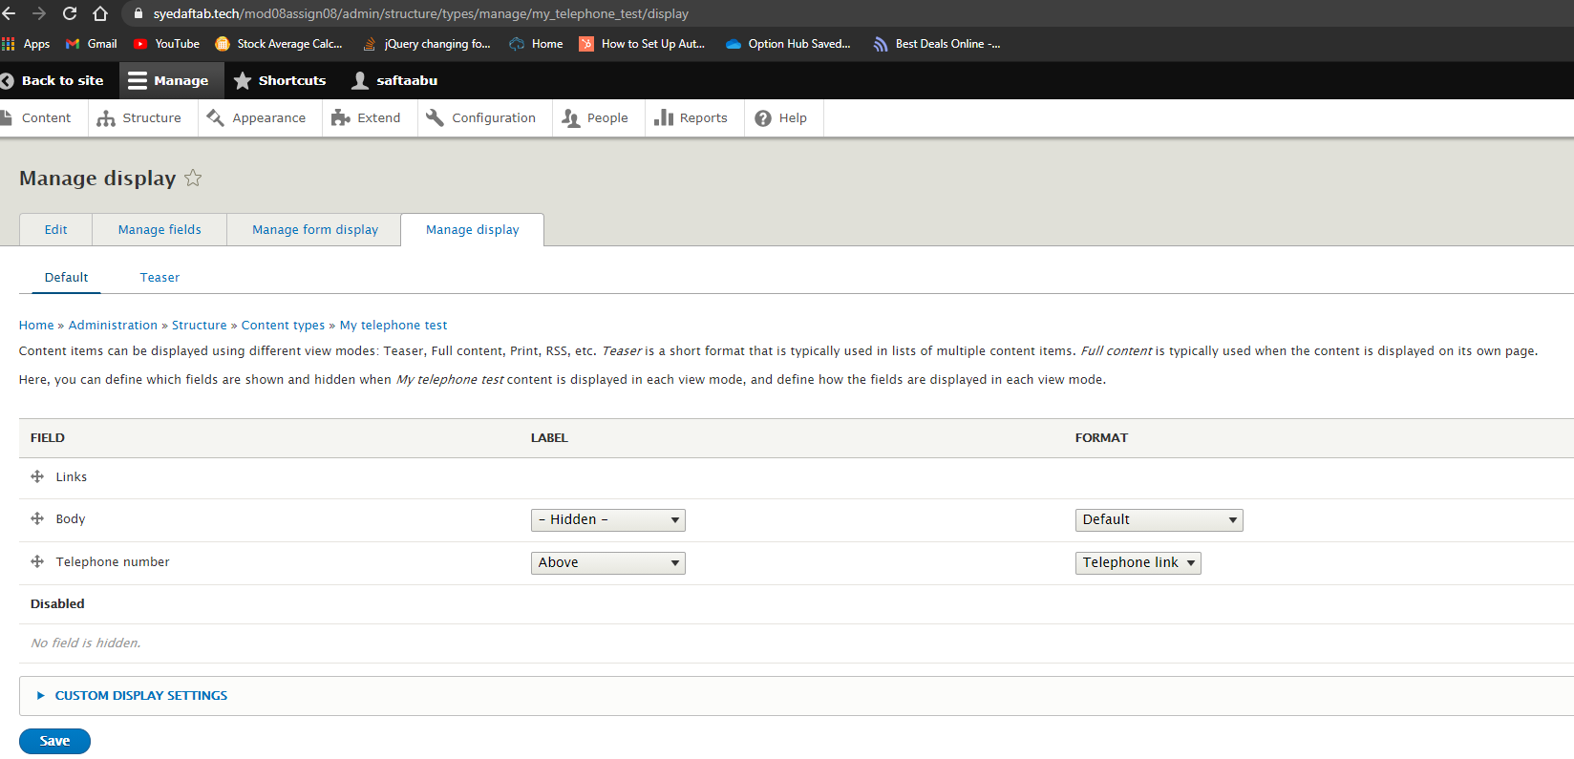]**

**3. SCREEN CAPTURE of the backend of Admin toolbar > Content, filtering for ‘My telephone test’ Content type [E03]  
[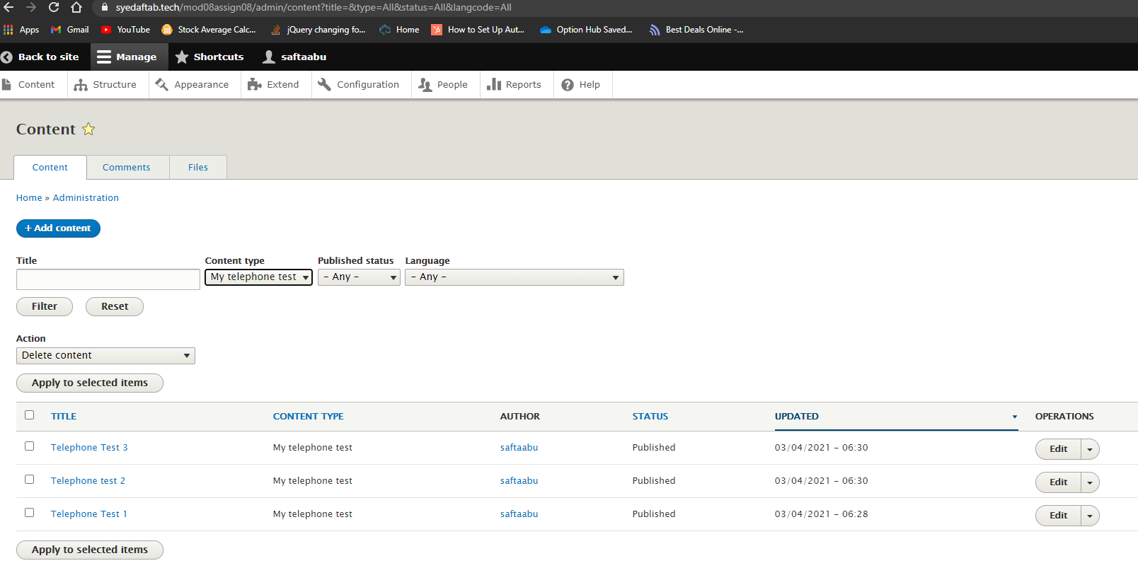]**

**4. SCREEN CAPTURE of the front-end website, as an anonymous user** after selecting the Main navigation link for one of the three (3) “My telephone test” menu items **[E04]  
[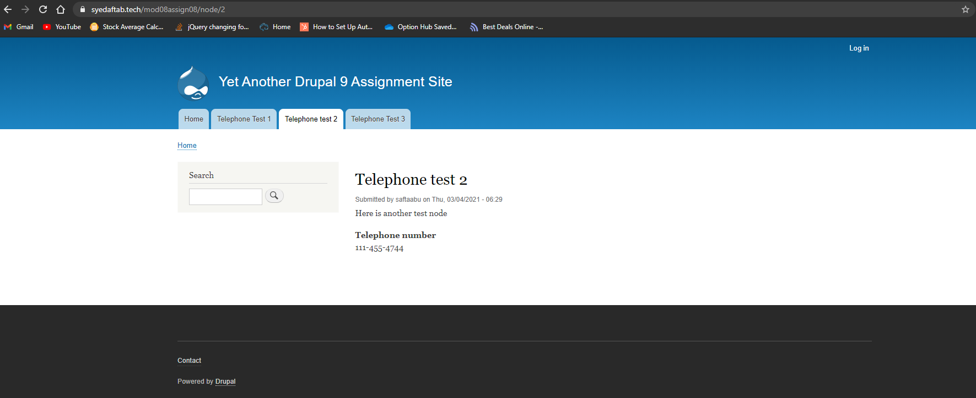]**

Part F – Create a new Codeanywhere Drupal 9 site

Drupal 9 Version Info:

1. Which website URL did you use to determine the most recent version of Drupal 9? **[F01]** **[**https://www.drupal.org/project/drupal/releases**]**
2. Which version of Drupal 9 did you select from the above website when you build the Drupal 9 site on your Codeanywhere account?   
   **[F02]**   
   **[**drupal 9.1.4**]**
3. Did you harden your Drupal 9 site on Codeanywhere? **[F03]**   
   **[YES]**

Codeanywhere account info: (So your instructor can login to your account and start the container connection)

1. **Codeanywhere account Username (email): [F04]** **[**saftaabu**]**
2. **Codeanywhere account Password:** **[F05] [**50297006@Sps**]**

Codeanywhere Drupal 9 Website Info:  
(So your instructor can login to your Drupal site as the site admin)

1. **Drupal 9 CMS Website URL:** **[F06] [**http://sa-assign08-ca-syedaftab299999760.codeanyapp.com/**]**
2. **Website Admin Username:** **[F07] [**saftaabu**]**
3. **Website Admin Password:** **[F08] [**50297006@Sps**]**

**Go back to the instructions and begin work on part G.**

Part G - Extend the Codeanywhere Drupal 9 Site with a Custom Module

1. SCREEN CAPTURE of the Codeanywhere file system, showing the Modules folder expanded and the custom module folder fully expanded  
   **[G01]**

**[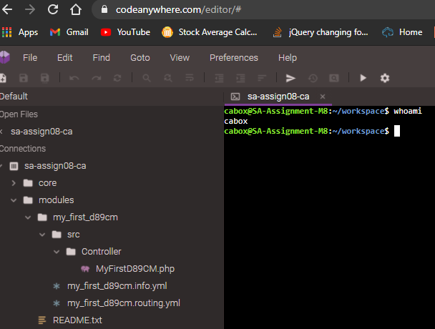]**

1. File name and SCREEN CAPTURE of your custom module info.yml file contents using an ASCII editor  
   **[G02]  
   [**info.yml file name: my_first_d89cm.info.yml**]**

**[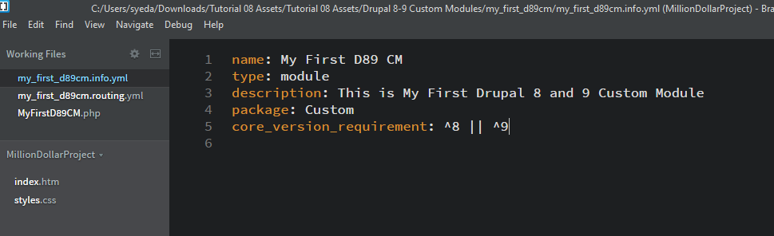]**

1. File name and SCREEN CAPTURE of your routing.yml file contents using an ASCII editor  
   **[G03]  
   [**routing.yml file name: my_frst_d89cm.routing.yml**]**

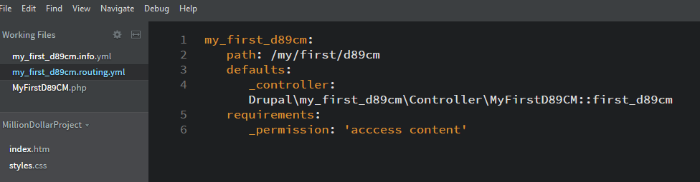**]**

1. Controller file name and SCREEN CAPTURE of your Controller file contents using an ASCII editor  
   **[G04]  
   [**Controller file name: MyFirstD89CM.php**]**  
   **[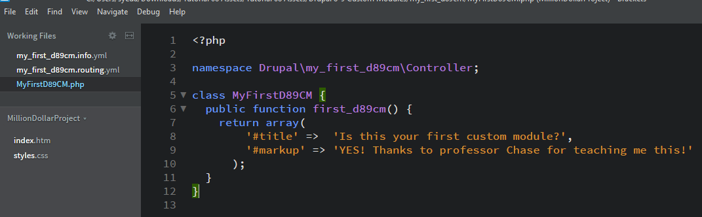]**
2. While logged into the Drupal 9 site, Access the custom plugin by adding its path to the end of the site URL then take a SCREEN CAPTURE of Drupal site   
   **[G05]**  
   **[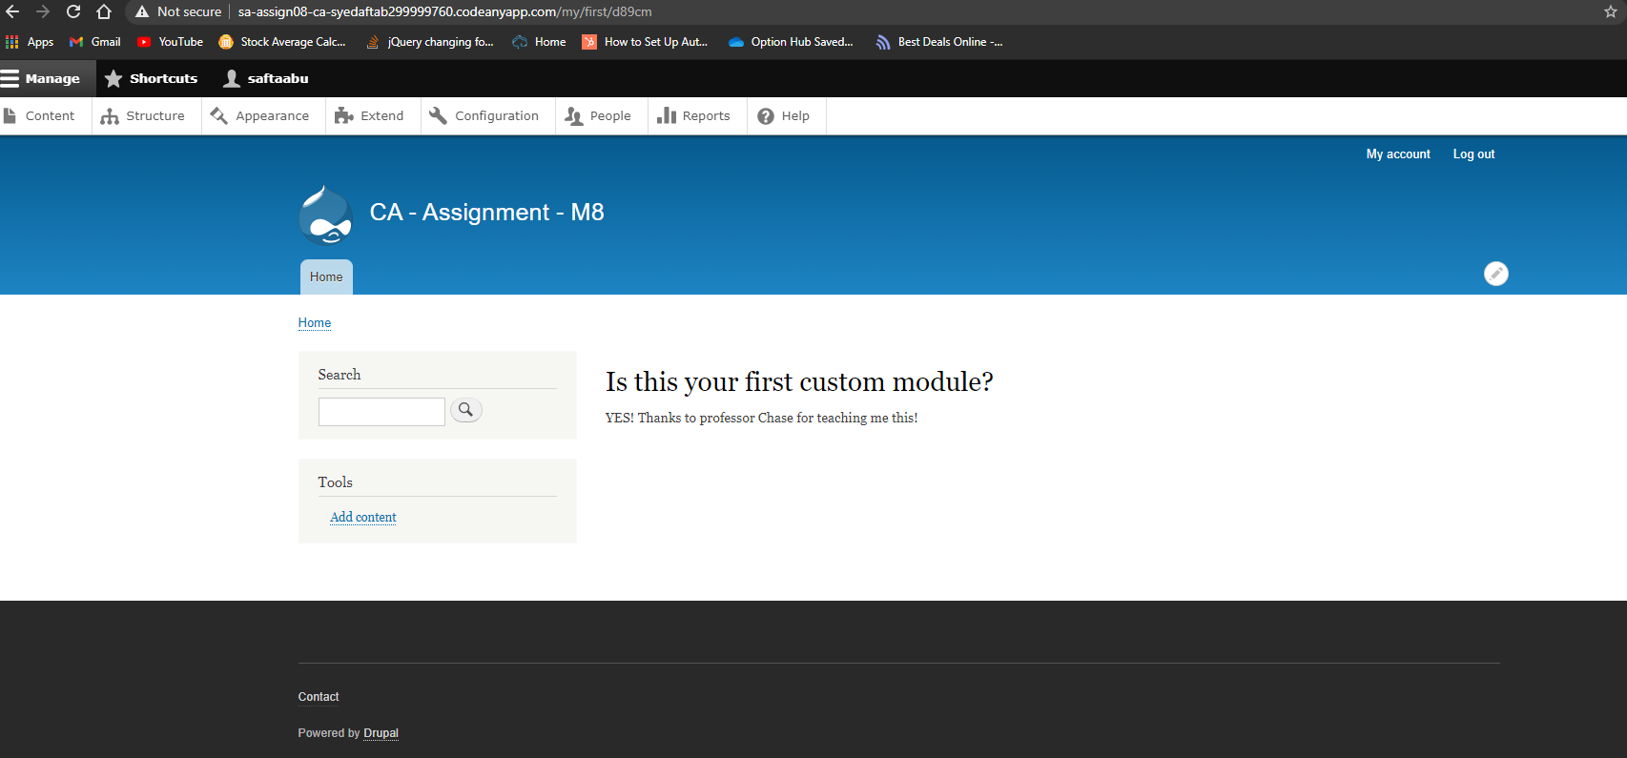]**

**Go back to the instructions and begin work on part H.**

**Part H – Assignment Wrap up: (REQUIRED)**

Answers to questions 1-3 are required to receive points for this section.

1. **Did you work with a tutor or volunteer on this assignment?   
   [H01]  
   [**NO**]**
2. **Did you have any problem or issues completing this assignment?   
   [H02]  
   This is not an optional question.   
   [**NO**]**
3. **If you answered yes for #2 above, please elaborate and be specific about the issues or problems you had (other than time management)  
   If you had trouble with a specific section, part, or question, please identify it by number and explain what you did not understand or had problems with below.   
   [H04]   
   *Required if you answered Yes above – Otherwise optional  
   [**Problem details or list of details here**]**
4. **If you answered yes for #2 above, did you contact the instructor or tutor for help and if not, your reasons why?   
   [H03]  
    [**Yes or No Answer and explanations here**]**